SOLENT RADIO CONTROLLED MODEL YACHT CLUB.
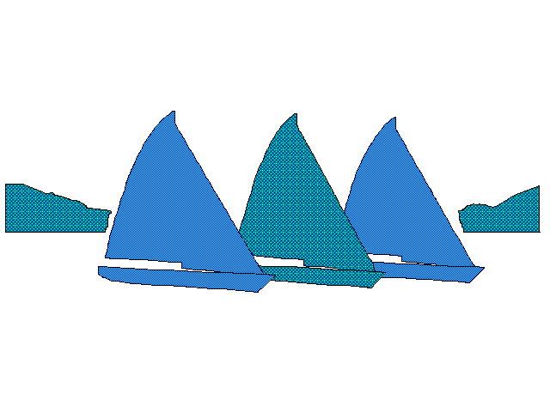
SAILING SECTION
APPLICATION FOR MEMBERSHIP

Full name:……………………………………………………………

Address:……………………………………………………………...

……………………………………………………………….

Post code:……………………………... Telephone No: …………………………..

e-mail:…………………………………. Mobile No:………………………………..

You are invited to apply for membership to the Solent Radio Controlled Model Yacht Club.
Your application will be tabled at the next committee meeting. The decision of the committee shall be final.
The Club is affiliated to the MYA and all yachts raced in club races must conform with the Class Rules. The Club measurer may inspect and measure any yacht used in club events. Members must be covered by MYA insurance. This is a condition of using Setley pond.
If you are already a MYA member, please state through which club and your membership number.

…………………………………………………………………………………………………………………..If elected, I agree to abide by the Club rules and the conditions set by the Forestry Commission for use of Setley Pond.

Signed: ……………………… Date:………………….

Proposer: ……………………………………… Date: ………………….

Seconder: ……………………………………… Date: ………………….
Membership is £28, but with externally paid MYA Insurance it is £18. (including joining fee of £2)
There are 3 different ways to pay, the first two preferred:
- By direct BACS transfer, please give your surname as a reference.
A/c number: 01153943 Sort code: 40-30-36
- By cheque payable to SRCMYC
- In cash to the treasurer.

The Club organises racing for the following classes; International One Metre, Marblehead, R36,
6 Metre, DF 95 and Admiral’s Cup (AC) yachts. Please circle the class or classes you wish to participate in.
Members are encouraged to use 2.4 GHz radio. If 27 or 40 Mhz is used, a frequency will be allocated for your exclusive use in club events.
It is recommended to keep an emergency number in the glove compartment of your car together with any medical information that would be useful to first responders.
Would you please list below:-
Membership of any other model yacht clubs: …………………………………………………………………..

Any experience you have of racing full size dinghies or yachts and please indicate if you know the racing rules.
……………………………………………………………………………………………………………...

Membership Secretary: John Bradshaw, 33, Princess Royal Close, Lymington, SO41 9 NY
E Mail: jgbraw@gmail.com Club website: www.srcmyc.org.uk (v. 18.1.1)

